**Question 1:** What were the sales for each Genre in France? What was the percentage contribution for each Genre? **(SQL 1);** How do the Genre sales compare with each other? **(SQL 2)**

**Figure 1.1: Genre Sales in France**

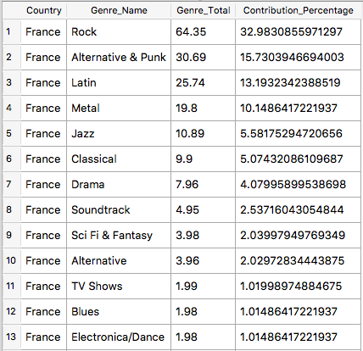

**Conclusion:** We can see that Rock has the highest sales out of all the other genres in France and Bossa Nova, Reggae, and Rock & Roll have the lowest sale. It’s easier to see how much each genre contributes to the overall sales in France by looking at percentages.

We see that Rock makes up about 33% of the overall sales and that Bossa Nova, Reggae and Rock & Roll make up .5% of the overall sales contribution. There’s a better visualization of the percentages shown in Figure 1.2.

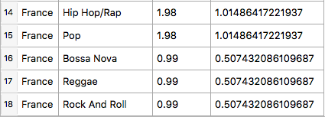

**Table 1a**: Genre Sales in France and

its percentage sales contribution

**Figure 1.2: Percentage Contribution of Genre Sales in France**

Macintosh HD:Users:Winnie:Desktop:Screen Shot 2018-11-24 at 3.43.12 PM.png

**Table 1b:** Average of all Genre Sales

The average of the overall genre sales in France is about $10.84. We see that only 5 out of the 18 genres have sales above the average, which are: Rock, Alternative & Punk, Latin, Metal and Jazz.

**Question 2:**

What were Canada’s yearly sales? **(SQL 3)**

|  |  |
| --- | --- |
| **Year** | **Sales** |
| 2009 | 59.4 |
| 2010 | 78.26 |
| 2011 | 53.46 |
| 2012 | 42.57 |
| 2013 | 72.27 |

**Table 2a**: Canada’s Yearly Sales

(SQL solution)

**Figure 2.1: Canada’s Yearly Sales Trend**

**Conclusion:** Based on Table 2a, Canada’s yearly sales are not consistent: sales hit its highest peak from $59.40 to $78.26 from 2009 to 2010 before it goes back down to low 50 in 2011, hit another low dip in 2012 before sales went up in 2013 with $72.27. This can be visualized in Figure 2.1. The sales seems to decrease in the years 2010-2012

In reality, sales numbers are usually much higher. It could be that this database query is not suitable for yearly sales analysis.

**Question 3**: What are the overall monthly sales of Rock music in 2013 throughout the world? **(SQL 4)**

|  |  |
| --- | --- |
| **Month** | **Sales** |
| March | $8.91 |
| April | $14.85 |
| May | $8.91 |
| June | $18.81 |
| July | $22.77 |
| August | $17.82 |
| September | $21.78 |
| October | $19.80 |
| November | $26.85 |
| December | $22.77 |

**Table 3a**: Quantitative Monthly Sales

**Figure 3.1:** Monthly Sales of Rock Music in 2013

**Conclusion:** As we can see from Figure 3.1, Rock music steadily increased throughout the months of March until the end of the year in 2013. By the month of December there has been a 2.5 time increase in sales since the month of March in 2013. Query results did not show any data from January to February for the year 2013.

**Question 4:**

What is the average length of Led Zeppelin’s music? **(SQL 5)**

How do they compare with the rest of his music? **(SQL 6)**

|  |  |
| --- | --- |
| **Average** | 351942.2281 |
| **Shortest Length** | 126641 |
| **Longest Length** | 1612329 |
| **# of Songs Above Average** | 39 |
| **Standard Deviation** | 206585.833 |
| **Median** | 289031 |

**Table 4a**: Comparison Values

**Conclusion**: The average length of Led Zeppelin’s music is about **351,942 milliseconds.** There are **114 tracks** under Led Zeppelin’s name. Out of them all **39 tracks** have lengths that are above the average length of all his music. We also see than half of the music lengths are longer than 289,031 milliseconds and half of the music lengths are shorter than that. Led Zeppelin’s shortest and longest song lengths are **126,641** and **1,612,329** milliseconds respectively. His longest song has a length that is about 4.5 times the average.

Another insight to note is that the average is larger than the mean. We can assume that the curve distribution with be skewed to the right, which is proven in Figure 4.1 below:

**Figure 4.1**: Curve Distribution of Led Zeppelin’s Song Length

From Figure 4.1, we see that the curve somewhat resembles a normal distribution. This could be due to large outliers stretching the data. This is supported by the fact that we have a large standard deviation of 206,585 because the larger the standard deviation, the wider the spread of the data points.